**HARDWARE: THE KEYBOARD & PERIPHERALS**

**VOCABULARY**

**KEYBOARD**

alt key tecla - alternativa

arrow keys - teclas de flechas

backspace key - tecla de retroceso

caps lock key - tecla bloqueo mayúsculas

command key - tecla de comando

control key - tecla control

delete key - tecla borrar

escape key - tecla escape

function keys - teclas de función

modifier key - tecla modificadora

numeric pad - panel numerico

return or enter key - tecla para retroceder o introducir

shift key - tecla de cambio

space bar - barra espaciadora

tab key - tecla tabuladora

**PUNCTUATION SYMBOLS**

*and* symbol - símbolo y

apostrophe - apóstrofe

asterisk - asterisco

*at* symbol - arroba

brackets - parentesis

colon - dos puntos

comma - coma

exclamation mark - signo de exclamación

full stop - punto

hyphen - guión

question mark - signo de interrogación

quotation marks - comillas

semicolon - punto y coma

slash - barra

underscore - barra baja

**PREPOSITIONS / PREPOSITIONAL PHRASE**

above - arriba

behind - detrás

below - abajo

between - entre

in the middle of - en el medio de

next to - junto a

beside - al lado de

on - en

over - encima

under - debajo

**PERIPHERALS**

barcode scanner - escáner de código de barras

flash drive - Unidad flash

gaming controller - controlador de juegos

headset - cascos

microphone - microfono

printer - impresora

projector - proyector

remote control - control remoto

scanner - escaner

speakers - altavoces

stylus pen - lápiz óptico

touch screen - pantalla táctil

USB charger - cargador usb

webcam - cámara web

**ORDERING**

broken - roto

obsolete - obsoleto

order - pedir

overstocked - sobrealmacenar

reorder - pedir de nuevo

run low on - estar quedándose sin

run out of - quedarse sin

**EXTRA!**

joystick - palanca de mando

laser pointer - puntero laser

letter keys - teclas de letras

memory stick - tarjeta de memoria

page down - página abajo

page up - página arriba

QWERTY - QWERTY

short cut -atajo

touchpad - panel táctil

**PRACTICE!**

**1 Match the keys in A to the correct action in B.**

| **A**  1. arrow keys  2. caps lock key  3. delete key  4. escape key  5. return or enter key  6. shift key  7. tab key | **B**  _2__ a. changes the text to capital letters  _5__ b. starts a new line  _7__ c. advances the cursor to the next tab stop  _6__ d. changes one letter to a capital or punctuation mark, or gives another option  _1__ e. move the cursor up, down, right or left  _3__ f. removes letters or words  _4__ g. cancels the current process or program running |
| --- | --- |

**2 Decide if the sentences are true or false.**

1. The space bar is smaller than the other keys. __False__

2. The control and alt keys perform actions when pressed with different letters. _True___

3. The backspace key deletes one position forward from the cursor. _false___

4. The numeric pad consists of maths symbols as well as numbers. _True___

5. The 12 function keys take you directly to different commands. _True___

6. The command key is also called the control key. _False___

7. A modifier key is only used in conjunction with another key. _True___

**3 Match the names to the punctuation marks.**

*full stop • at symbol • slash • question mark colon • semicolon • and symbol • apostrophe quotation marks • comma • brackets • asterisk hyphen • exclamation mark • underscore*

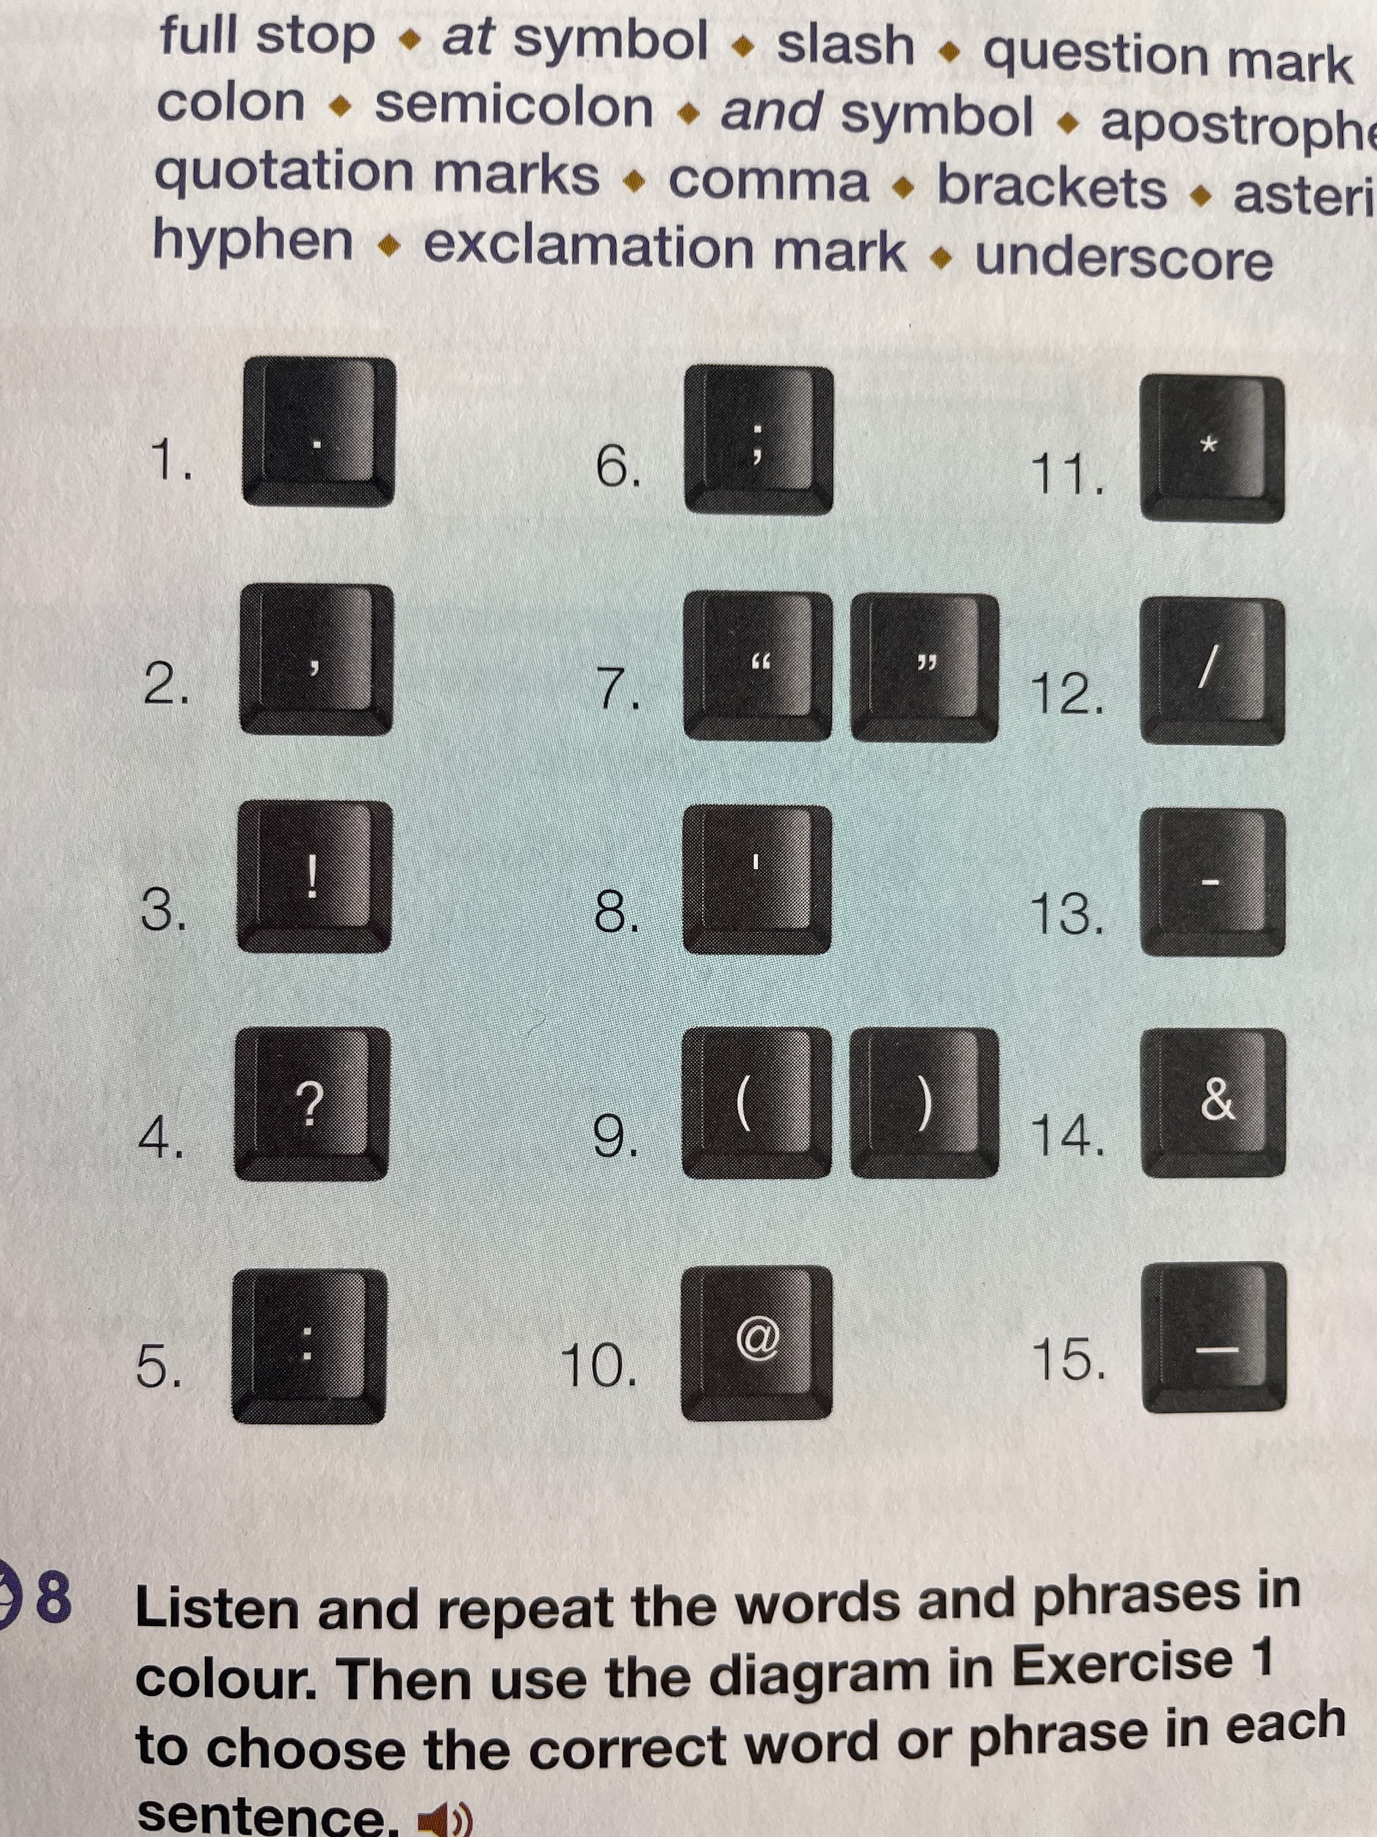

1.full stop

2.comma

3.exclamation mark

4.question mark

5.colon

6.semicolon

7.quotation marks

8.apostrophe

9. brackets

10.at symbol

11.asterisk

12.slash

13.hyphen

14.and symbol

15.underscore

**4 Match the words to the pictures.**

scanner • speakers • projector • microphone • stylus pen webcam • headset • printer • gaming controller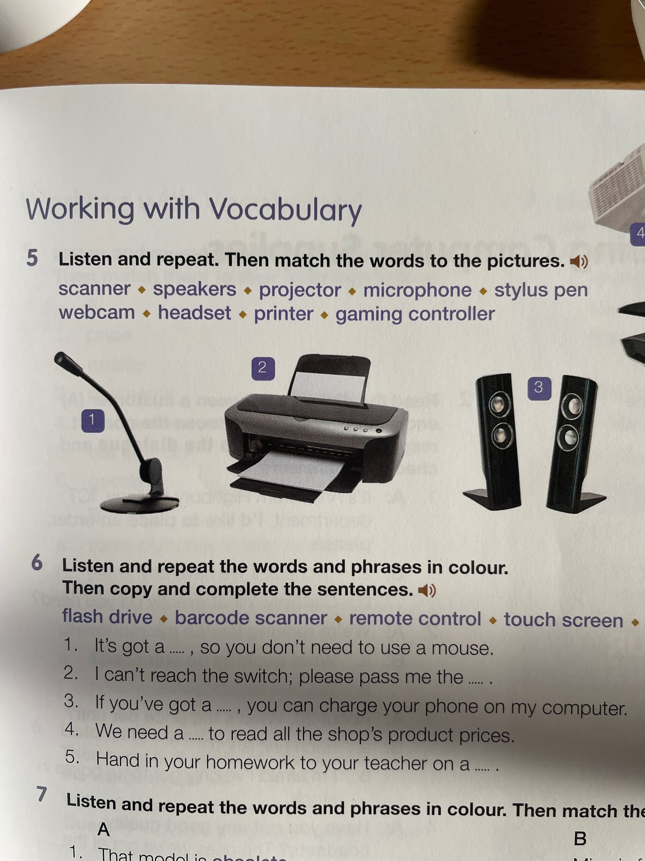

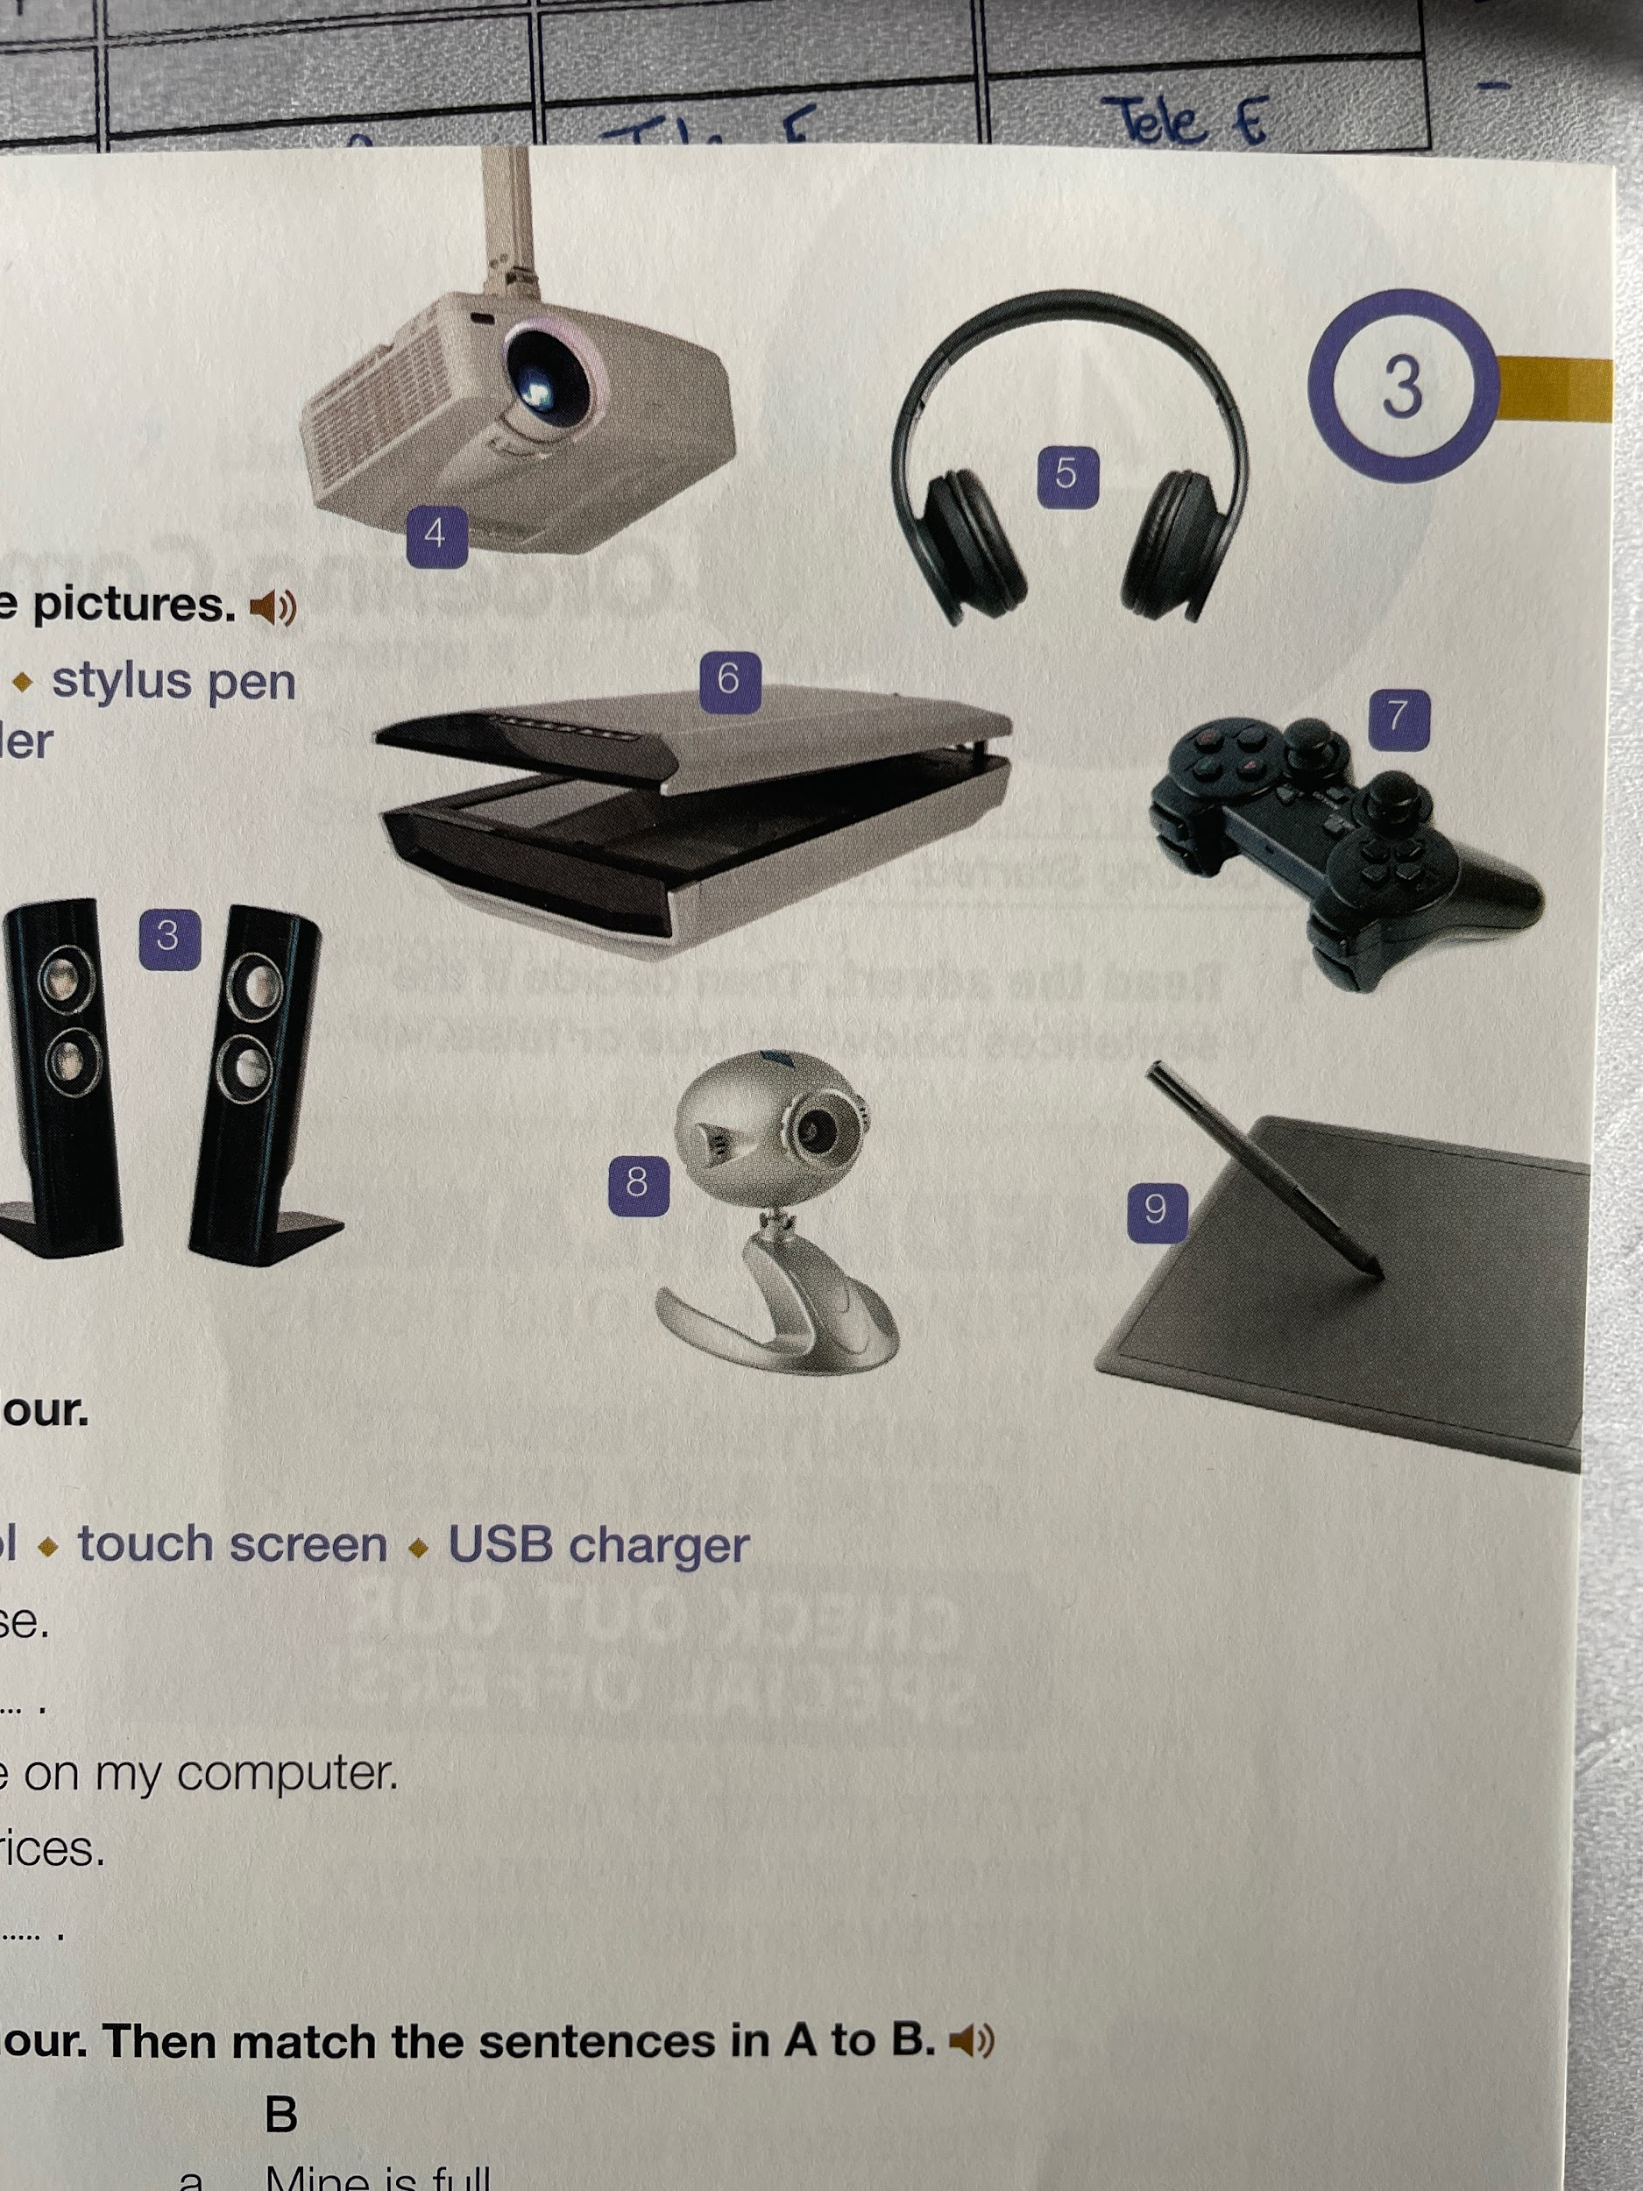



1. __microphone_____________________
2. __printer_____________________
3. __speackers_____________________
4. __projector_____________________
5. __headset_____________________
6. __scanner_____________________
7. __gaming controller_____________________
8. __webcamb_____________________
9. __stylus pen_____________________

**5 Complete the sentences.**

*flash drive • barcode scanner • remote control • touch screen • USB charger*

1. It's got a ... , so you don't need to use a mouse. touch screen

2. I can't reach the switch; please pass me the .....remote control

3. If you've got a ..., you can charge your phone on my computer. USB charger

4. We need a … to read all the shop's product prices. barcode scanner

5. Hand in your homework to your teacher on a … .flash drive

**6 Match the sentences in A to B.**

| **A**  1. That model is obsolete.  2. Can you please order a new flash drive for me?  3. The fax machine is broken.  4. We're overstocked with mouses.  5. We need to reorder with that supplier.  6. We've run out of USB chargers.  7. The printer has run low on ink. | **B**  _2__ a. Mine is full.  _4__ b. There are 97 in this box!  _1__ c. They don't make or use it any more.  _6__ d. We didn't bring enough to the trade exhibition.  _3__ e. It's not receiving information again.  _7__ f. I can't see the words properly.  _5__ g. We last ordered with them three months ago. |
| --- | --- |

**7 Read the email to the IT department. Complete the sentences with the words from the exercises above.**

Dear Zoe,

Thanks for your help and cooperation with the annual inventory:

All of the **obsolete**  hardware is going to be replaced over the next 12 months.

In addition, the sales staff need two new **touch screen** for their presentations to their customers.

We have ordered a box of **headsets** and **microphones** to improve sound quality for the help desk.

We have to replace the colour printer in the art department because it is **broken** and it costs too much to fix.

The webcams we ordered last month haven't arrived, so we are going to **reorder** them.

John Worth

IT Manager